**Hospital Management**

**System**

Requirements Specification

and Analysis

Version 1.0

*22.11.2020*

KITA - Group 5

Prepared for

SE301 Software Engineering



1. **Introduction**

**1.1) Purpose of the System**

This project is a website which offers a useful online Hospital Management System that can be used by patients, doctors, hospital admins, other hospital personnel. Everyone who wants to get information about the hospital and the departments, or the doctor who works in that hospital, will be able to find their answers by using this system. Every person who wants to get a treatment in the hospital can use this system to book their appointment, view the appointment and can cancel their appointments afterwards. For the hospital personnel, the purpose of this system is to be able to view their appointments day by day, to see their patient’s information and older and newest test results by using the system, and they will be able to inform their patients by using the system. They can enter the information about the diagnosis or medicine list to the system easily.

**1.2) Scope of the System**

Scope of our Hospital Management System is to make the system easy to use for patients, admin, doctors, other hospital personnel, whoever wants to use this program. The program should offer a clean and understandable interface, can be readable by every type of user, should answer every purpose related with the hospital and of course should make it as fast as possible. Our main goal is to satisfy all types of users related to the hospital.

**1.3) Objectives and Success Criteria of the Project**

Our objective is to build every aspect of the system successfully, make the system work properly, minimize the system failures even if it is not possible to eliminate.   
Our success criteria for our project for the hospital management system is to complete all of our objectives, make the subjects work successfully and build the system in the allotted time and the allotted time for our project is the end of the 2020 Fall semester.

1. **System Requirements**

**2.1) Functional Requirements**

**Admin:** Admin needs sign up and login to the hospital management system to control the system. After login, admin can create, view, approve, reject or delete doctor and patient accounts. Admin can book for appointments for the patient, after that if required admin can also cancel appointments. Admin can view appointments. After a patient applies to book an appointment, Admin needs to approve or reject it. Admin can see total doctor, patient and appointment numbers saved in the system. After an appointment, admin needs to create invoice pdf, after creating invoice pdf will be able for viewing.

**Doctor:** Doctors need to apply for jobs to be able to create an account in the system. Admin will view the doctor’s CV and if the doctor gets the job, then the admin will create the account for the doctor. After the account is created, the doctor can login.

Doctors can view their patient’s details, only the patient’s that are assigned for the doctor.

Doctors can view the appointments that are approved by the admin, also can view the discharged patient list and their details on the Patient Page. Doctors can edit the Patient’s diagnosis and symptom details on Patient Page. Doctors can edit the recipe page for the medicine after diagnosis on the Patient Page.

**Patient:** Patient can sign up the system and create an account. But admin approval is necessary to login the account. After the admin approves the account, the patient can login. Patients can change their information details on their patient page(like mobile phone, address etc.) Patients can use the system to book appointments. After the appointment is approved by the admin, patients can use change or cancel functions. Patients can view their patient page and view the diagnosis and symptom page and recipe page. Patients can view the appointment status and will be notified by the system after approve/reject is given by the admin. Patients can see the doctor list and details, and can choose a doctor for appointment. Patients can view the invoice pdf and download it after treatment is done.

**2.2) Nonfunctional Requirements**

**Usability**

Even the first time users should understand the system and use the system easily. The system should give a short tutorial or how-to-use page for the first login. There should be a definition for the functions of the system and these definitions should contain short but easily understandable sentences. The design should be simple and the buttons should be easily accessible.

**Reliability**

The system's safety and security is so important because the system will save the data such as personal information like addresses, phone numbers, identity numbers. For example, any patient should not be able reach to the other patient’s or the doctor’s personal information.   
On the other hand, we need that the system should be reliable. It means that the system needs to have data loss tolerance, it should save the backup data daily and this backup data should be accessible immediately if needed but the system should not allow anyone to abuse the backup data or the actual data. The system should easily handle the exceptions. No one needs a system that crashes easily.

**Performance**

The response time of the system is so important. When a user's request an operation and response time goes like 1 minute or even more, the user is not going to like the bad performance and is going to look for a better system. So it is so important to answer the users' needs.   
We should keep in mind that not only one or two users are not going to use the system; maybe hundreds of people will use it at the same time, so the system should carry the load even if it is heavy. :)  
So the system should support all of the concurrent users easily and properly.

**Supportability**System should be available for updates and new versions but should be open for usage after the updates and should prevent any loss of saved data after the update. System should have the maintenance ability. Maintenance should help correction of errors and exceptions.

**Implementation**

Our website will be supported by all types of browsers for example Google Chrome, Mozilla, Firefox.   
Programming Languages we are going to use for this project are : Python, SQL and HTML.

IDE’s that we are going to are : PyCharm, PostgreSQL.

**Interface**

The system will use three different types of interface which is patient interface, doctor interface and admin interface. These three interfaces contain different functions and usage which satisfy all types of user’s requirements.

Admin should reach almost every operation that is included to the system.  
Patients should reach their own information, doctor list and should be able to book, view, cancel their appointments.   
Doctors should view their appointments, calendar, their profile and information page, patient’s information page etc.

Their login page also should be different and their id and password should be unique.

**Packaging**

Since this is a website system, anyone who has any type of computer which is connected to the internet, can access the system. So no installation required.

**Legal**

Our website will contain a payment system so it should have a 3D secure system which is legal and used for most of the websites which use a payment method.  
The system should inform the users with a protocol that is prepared and users should read and accept so their personal information will be kept under their permission.

1. **System Models**

**3.1) Use Cases**

|  |  |
| --- | --- |
| Use Case | SignUp |
| Participating Actor | Users:Patient, Admin |
| Flow of Events | Users sign up to the system with their name and password. System add their account to databaseSystem request their name, surname, gender, age, address, mobile.  Users should fill requests |
| Entry Condition | Writing their name and password.  Then all requests. |
| Exit Condition | When the steps finished for sign up condition.  System save the user to database |
| Quality Requirement | If any request is empty or the request type is not correct .  System will give the error message |

|  |  |
| --- | --- |
| Use Case Name | ApproveAccount |
| Participating Actor | Admin |
| Flow of Events | After the patient signed up for the system, admin approval was required. |
| Entry Condition | Patient register to the system. |
| Exit Condition | Admin approves the account. |
| Quality Requirement | If there is an error during approving the account, page not answers etc. leave an error message. |

|  |  |
| --- | --- |
| Use Case Name | ApplyForJob |
| Participating Actor | Doctor, Admin |
| Flow of Events | Doctors can apply for jobs, upload their CV and other required information. Admin can view this page and after that he/she can communicate with the doctor by using the info, and book a meeting. |
| Entry Condition | Doctors apply for the job,  Upload the requirement files. |
| Exit Condition | Doctor sends the info and requests. After that admin can view this. |
| Quality Requirement | If there is an error during upload, of approval send an error message. |

|  |  |
| --- | --- |
| Use case name | Login/Logout |
| Participating Actor | Users:Admin, Doctor, Patient |
| Flow of events | Users enter their name and password.  System checks their name and password from the database. |
| Entry Condition | Writing name and password to system |
| Exit Condition | Web page open in the same page according to their account |
| Quality requirement | If there is an intrusion attempt more than 10, System will ask.  An logical question to user |

|  |  |
| --- | --- |
| Use case name | Appointment |
| Participating Actor | Patient, Admin, Doctor |
| Flow of events | The patient can book an appointment.  The patient should enter a description of the symptom and doctor’s name and department.  The admin can view the appointment then the admin is able to approve or reject it.  Also patients can cancel the appointment.  In some cases, the admin can make an appointment.  Doctors can only view the appointment list.  Users list all the appointments of patients in the hospital system from a database with their details. |
| Entry Condition | The patient logged into the booking appointment system. |
| Exit Condition | The patient takes a return appointment day and time. |
| Quality requirement | If the admin doesn't approve or reject the appointment in a one day.The appointment will be approved by the system. |

|  |  |
| --- | --- |
| Use Case | Book Appointment |
| Participating Actor | Admin, Patient |
| Flow of Events | After the patients enter the Appointment page, they can enter the book appointment page. They can choose the doctor and the date they want to book for the appointment, then will be able to book their appointment. Also admin can book appointments for patients. Admin does the steps instead of the patients. It will work if a patient wants to book an appointment by calling the hospital. |
| Entry Condition | Patient/admin enters the date, department and doctor they want to get treatment. |
| Exit Condition | Appointment sent for approval by admin, end patient can view the status on the page. |
| Quality Requirement | If the date, department or doctor info is missing or wrong, gives an error message. |

|  |  |
| --- | --- |
| Use Case | Approve Appointment |
| Participating Actor | Admin |
| Flow of Events | Admin views all the appointment request list of patients in the system from the database with their details, then the admin can approve the appointment. |
| Entry Condition | When the admin logged and listed the request for the appointment in the hospital system. |
| Exit Condition | Admin approves the appointment. When the approval of the appointment is completed, the admin can logout. |
| Quality Requirement | If the admin doesn't approve the appointment in one day, the system will approve the appointment automatically. |

|  |  |
| --- | --- |
| Use Case | Reject Appointment |
| Participating Actor | Admin |
| Flow of Events | Admin views all the appointment request list of patients in the system from the database with their details, then admin can cancel the appointments. |
| Entry Condition | Admin login and enters the appointment page. |
| Exit Condition | When the rejection of the appointment is completed, the admin can logout. |
| Quality Requirement | If the admin doesn’t reject the appointment in one day, system will approve the appointment automatically. |

|  |  |
| --- | --- |
| Use Case | Cancel Appointment |
| Participating Actor | Users : Admin, Patient |
| Flow of Events | Patients can cancel the appointment before the appointment date. Admin can cancel the appointment if the patient or doctor requests it. (There can be an unexpected condition in the program. ) |
| Entry Condition | Patient or admin login and cancel the appointment. |
| Exit Condition | The appointment is canceled by users. |
| Quality Requirement | If the admin cancels the appointment, the patient will be noticed about the changes by system. |

|  |  |
| --- | --- |
| Use Case | View Appointment |
| Participating Actor | Users:Admin,Patient,Doctor |
| Flow of Events | Doctors list all the appointments of patients in the hospital system from a database with their details. |
| Entry Condition | When the Doctor logins, s/he can request an appointment list. It will be shown in the appointment details tab. |
| Exit Condition | When the control of the appointment is completed, the Doctor can logout. |
| Quality Requirement |  |

|  |  |
| --- | --- |
| Use Case | View Doctor List |
| Participating Actor | Users:Patient, Admin |
| Flow of Events | Users can view all doctor list in web page  System should get the data from database |
| Entry Condition | When users log in and request a doctor list in the hospital system. |
| Exit Condition | Users get the list in the web page |
| Quality Requirement | If the system doesn't give the document in 30 sec .System will give an error message that is overtime operation. |

|  |  |
| --- | --- |
| Use Case | Create/Edit Symptom and Diagnosis |
| Participating Actor | Doctor |
| Flow of Events | Doctors can select a patient from a patient list .  Then the doctor can select or enter the symptoms and diagnosis. The doctors are able to change these data |
| Entry Condition | Doctors select the patient name then select or enter the symptoms and diagnosis |
| Exit Condition | System saves these data to the database. |
| Quality Requirement | If a doctor enters the symptoms and diagnosis which are not valid.  System request an explanation of these symptoms and diagnosis |

|  |  |
| --- | --- |
| Use Case Name | EditProfile |
| Participating Actor | Users:Patient, Doctor |
| Flow of Events | The Users can enter their personal information on this page like phone number, address, e-mail address |
| Entry Condition | Users write the information. |
| Exit Condition | Systems saves the information and will be available for viewing on the profile page. |
| Quality Requirement | If any of the information is missing or not saved, there will be an error message. |

|  |  |
| --- | --- |
| Use Case Name | PatientPage |
| Participating Actor | Doctor, Admin,Patient |
| Flow of Events | This is a page where a doctor or admin can write the patient's symptoms, diagnosis, cure, required medicines. This page also will save the tests results for patients.  The patient only can view this page. |
| Entry Condition | Doctor or admin writes the results that are coming from the tests..  Patient select the information page |
| Exit Condition | Systems saves the information and will be available for viewing on the patient page.  The patient able to see and download the page |
| Quality Requirement | If any of the information is missing or not saved, there will be an error message. |

|  |  |
| --- | --- |
| Use case name | Invoice |
| Participating Actor | Patient, System, Doctor |
| Flow of events | Admin(system) can create invoice.pdf.  The patient is able to take a pdf document of the invoice from the system.  System should calculate the invoice of the operation. Patient and doctor can view the invoice pdf. |
| Entry Condition | Admin creates the invoice page and enters the details. Patients or doctors request an invoice from the system. |
| Exit Condition | System gives a pdf document of the invoice to the patient. |
| Quality requirement | If the system doesn't give the document in 30 sec . System will give an error message that is overtime operation. |

|  |  |
| --- | --- |
| Use Case Name | View Invoice |
| Participating Actor | Patient, Admin, Doctor |
| Flow of Events | Patient, doctor or admin can view the invoice pdf after the pdf is created by the system. They can also download the pdf. |
| Entry Condition | Patient, doctor or admin request to view the invoice pdf. |
| Exit Condition | Invoice pdf page is opened or downloaded as requested. |
| Quality Requirement | If the page is not open in 1 minute, the system returns to the home page. |

|  |  |
| --- | --- |
| Use Case Name | GetPayment |
| Participating Actor | Doctor |
| Flow of Events | Doctors can use this to get their payment monthly. |
| Entry Condition | Doctor requests for the payment. |
| Exit Condition | Doctor takes his/her payment. |
| Quality Requirement | If the time that the doctor requests for the payment is not matching with the determined payment time, the page gives an error message and writes the payment day. |

|  |  |
| --- | --- |
| Use Case | Admin Panel |
| Participating Actor | Admin |
| Flow of Events | Admin sign up to Dashboard with their username and password.  Control panel of the all system will open. |
| Entry Condition | Writing their username and password on a special website link. |
| Exit Condition | When the steps finished and save changes, then admin can log out. |
| Quality Requirement |  |

**3.2) Scenarios**

**Scenario Name:** Appointment

**Participating Actors & Instances:** Lewis & Admin  
**Flow of Events**: Lewis enters the Hospital Management System. Lewis wants to get treatment in the hospital. Lewis logins the system by using his id and password. Lewis enters the appointment page. He can see the department and doctor list on this page and Book Appointment button. If Lewis wants to book an appointment, he clicks the “Book Appointment” button and the page opens. He chooses the department he wants to get treatment in, chooses the doctor, and can view the available dates and hours. He chooses the date and hour then he sends the appointment request.   
After that, the admin is being noticed by the system about the appointment. He enters the page and approves or rejects the appointment request.  
If Lewis wants to cancel the appointment after the approval is done, he enters the page, logs in, and chooses the appointment on the appointment list, and cancels as he wishes.

**Scenario Name:** Book Appointment

**Participating Actors & Instances:** Lewis & Admin  
**Flow of Events:** Lewis enters the Hospital Management System. Lewis wants to get treatment in the hospital. Lewis logins the system by using his id and password. Lewis enters the appointment page. Lewis clicks the “Book Appointment” button on the page. After the page opens, he can view the department, the doctor list and the available dates. He chooses the general surgery department, he chooses Doctor Brain and chooses the date 15.12.2021 at 14.00 p.m. After he chooses all the necessary information, he sends the appointment request and waits for approval.   
After the request is sent, the admin views the appointment request and approves it.   
After the approval is completed, Lewis is informed by a system message when he enters the system.

**Event 2:** Lewis calls the hospital phone. Admin answers the call. Lewis says that he wants to book an appointment.   
Admin logins the system by his/her id and password. He opens the “Book Appointment” page. He needs to enter the Patient’s ID so he asks the patient’s information. Lewis gives the necessary information. Admin asks for the department, doctor and date for appointment. Lewis says the answers and admin books the appointment for Lewis.

**Scenario Name:** Cancel Appointment

**Participating Actors & Instances:** Lewis & Admin  
**Flow of Events:** Lewis enters the Hospital Management System. Lewis wants to get treatment in the hospital. Lewis logins the system by using his id and password. Lewis enters the appointment page. Lewis clicks the “Vied Appointment” button, now he can see the appointments that belong to him. Then he enters the “Cancel Appointments” page and he chooses the appointment that he booked one day ago and clicks the “Cancel” button. His appointment is being cancelled by the system. He can return the appointment page and book a new appointment.  
Event 2: Lewis calls the hospital phone. Admin answers the call. Lewis says that he wants to cancel his appointment. Admin logins the system by his/her id and password. He opens the “Cancel Appointment” page. He needs to enter the Patient’s ID so he asks the patient’s information. Lewis gives the necessary information. Admin gives info about the appointments that are booked by Lewis and Lewis says the appointment he wishes to cancel. Admin cancels the appointment for Lewis.

**Scenario Name:** Approve Appointment

**Participating Actors & Instances:** Admin  
**Flow of Events:** Admin enters the system by using his id and password. He can view the listed awaiting appointments that he needs to approve or reject. He controls the appointment made by patient Lewis. He checks for the date, for the info that Lewis entered and sees that everything is complete and okay. He approves the appointment request. Lewis is informed by the system after the approval is made.

**Scenario Name:** Reject Appointment

**Participating Actors & Instances:** Admin  
**Flow of Events**: Admin enters the system by using his id and password. He can view the listed awaiting appointments that he needs to approve or reject. He controls the appointment requests, he controls the appointments that are made by patient Lewis and he sees that the date of the appointment overlaps with the doctor’s conference. He rejects the appointment and writes the reason for rejection so Lewis is informed about the rejection by the system message.

**Scenario Name:** View Appointment

**Participating Actors & Instances:** Admin & Doctor Brain & Lewis  
**Flow of Events:**

**Event 1:** Admin opens the Hospital Management System. He enters his id and password, and logs into the system. He wants to see the appointment for today. He opens the View Appointment page, chooses the date and views the appointments, the patients’ information and the doctors that are assigned for the appointment.

**Event 2:** Lewis opens the Hospital Management System. He enters his patient id and password, and logins the system. He wants to see his appointments. He enters the “View Appointment” page and he can view the appointments. He can see his awaiting appointments, canceled appointments, booked appointments and the old appointments.

**Event 3:** Doctor Brain opens the Hospital Management System. He enters his doctor id and password, and logs into the system. He wants to see his appointments. He enters the “View Appointment” page and can view his appointments, the patient's name and other information for the patient who booked the appointment and the date of the appointment.

**Scenario name:** Patient Page

**Participating actor instances:** Bob :patient , Alice: Doctor , John:Admin

**Flow of events :** Bob wonder the patient page and he enter KITA the Hospital web page

When Alice do a test on patient , she write the write the patients symptom, diagnosis, cure required medicines on patient page.If there is a any new issues Also Alice can write these too

.Sometime doctors don’t have enough time .If Alice does not have enough time to write these data , John can write these data for Alice.

**Scenario Name:**SignUp

**Participating Actors & Instances:** Bob:Patient , John:Admin

**Flow of Events**: Bob thinks he needs to sign up to any hospital system and he decides to sign up KITA the Hospital web page. Because he is a man who cares about his health. Then he opens the web site. Filling the empty box that contains the request name, surname, birthdate, email, confirming password. Then Bob’s request to sign up goes to the admin's page then admin approves his account.

John is a new admin in the Hospital and he needs to sign up for the system. Also admin should fill the same boxes. Then another admin approved his account. If there is no admin in the web system. First admin gives an admin access to himself.

**Scenario Name:** Approve Account

**Participating Actors & Instances:** John:Admin

**Flow of Events :** John’s duty check every day in his admin page . there can be some requests on this page. And one of these approving the account.For patients, John approves or rejects their account .John should check if the patient information is correct or not. For Doctor, John should check the doctor's CV then he should prepare a meeting face to face. After that, only John can hire doctors to work.

**Scenario Name:** Apply For Job

**Participating Actors & Instances:** Berk:Doctor, John:Admin

**Flow of Events:** Berk is a doctor who have just graduated.He was looking for a job from internet he see the KITA the Hospital web page and he go to system and fill the form that request his name , surname , age, e-mail , address , graduated-school and previous job if its valid.CV(Curriculum vitae)

He prepares his information and he is waiting for hiring. Then Admin checks the job applications. And the admin sees Berk's application. Then the admin decides to meet him face to face .He calls Berk and invites him to the meeting. If the meeting goes in a good way. After that the admin can hire him.

**Scenario Name:** Edit Profile

**Participating Actors & Instances:** Bob, Akın:Patient, Berk:Doctor

**Flow of Events:** Bob just moved to another neighborhood. He realized he should change his address on the Hospital Web page. So he enters the Hospital web page. And he changes the information about the address and he saves the information. And he exited the system.

Akın lost his mobile phone. So he needed to change his phone number as well. He entered the Hospital web page. And he changed his new phone number he saved and exited the system.

Berk gives the personal email to the system that’s why he takes a lot of mail from the system. and he wanted to change his email address as a new one. So he opened the edit profile page then he changed the information and he saved and exited.

System updates these information immediately to the database after checking the information type.

**Scenario Name:** GetPayment

**Participating Actors & Instances:** Berk:Doctor

**Flow of Events:** Berk is excited. Because he will take his first Payment in his first month . So he request the system for payment.When Berk take payment he is so happy for it

System checks the date of Berk’s payment date. If the payment date is correct then

Berk can take his payment. If it's not the system give a message that says “your payment date has not come”.

**Scenario Name:** Login Successfully.

**Participating Actors & Instances:** Admin: Admin

**Flow of Events:**

Admin comes to his/her office in the hospital in the morning and turns on own computer.

Clicks "Admin" on the first page of the hospital system and reaches the Login page for admin.

On this page, the admin enters the system by entering his name and password.

**Scenario Name:** Login Unsuccessfully.

**Participating Actors & Instances:** Dr. Bob: Doctor

**Flow of Events:**

DoctorBobcomesto his office in the hospital in themornin and turns on his computer.

Click "doctor" on the first page of the hospital system and reach the Login page for doctors.

On this page, the doctor enters the system by entering his name but he is entering his password incorrectly and getting an error message is unable to login to the system.

**Scenario Name:** PatientPage

**Participating Actor & Instances:** Bob :patient, Alice: Doctor, John:Admin

**Flow of Events :** Bob wonder the patient page and he enter KITA the Hospital web page

When Alice does a test on the patient, she writes the patient's symptoms, diagnosis, cure, required medicines on the patient page. If there are any new issues Also Alice can write these too. Sometimes doctors don’t have enough time. If Alice has not enough time to write these data, John can write these data for Alice.

**Scenario Name**: CreatingInvoice

**Participating Actors & Instances:** Dr. Bob: Doctor, Alice: Patient, Admin: Admin

**Flow of Events:**

The Invoice is created by the admin for Alice, whose treatment is completed at the hospital, while returning home from the hospital.

Doctor Bob logs in to the hospital management system and views his patient list.

Dr. Bobchoose Alice from his patient list and looks at the invoice prepared for his patient Alice from the system to make sure that the invoice is prepared correctly and makes sure that it is correct.

Alice also logs in to the system before going to the payment and checks how much she will pay from the bill prepared for her.

**Scenario Name:** Create&EditSymptomAndDiagnosis

**Participating Actors & Instances:** Dr. Bob: Doctor, Alice: Patient

**Flow of Events:** Alice comes to the hospital with a sore throat. Doctor Bob logs into the system and records it as a symptom of Alice in his patient list. The next day, Alice begins to suffer from shortness of breath and doctor Bob records this new symptom of Alice into the system. As a result of his tests, Doctor Bob diagnoses Alice with the flu and records this diagnosis into the system as the diagnosis of Alice on his patient list.

**Scenario Name:** viewDoctorList.

**Participating Actors & Instances:** Admin: Admin, Alice: Patient

**Flow of Events:** Alice wonders if there is a cardiologist doctor at the hospital. Alice logs in to the hospital system as a patient and displays the doctor list. At that time, Admin wonders if the list of doctors working at the hospital is correctandlogsintothehospitalsystem as Admin. Admin displays the doctor list from the doctors section and makes sure there is no problem.

**3.3) Object Models**

**3.3.1) Use Case Diagram**

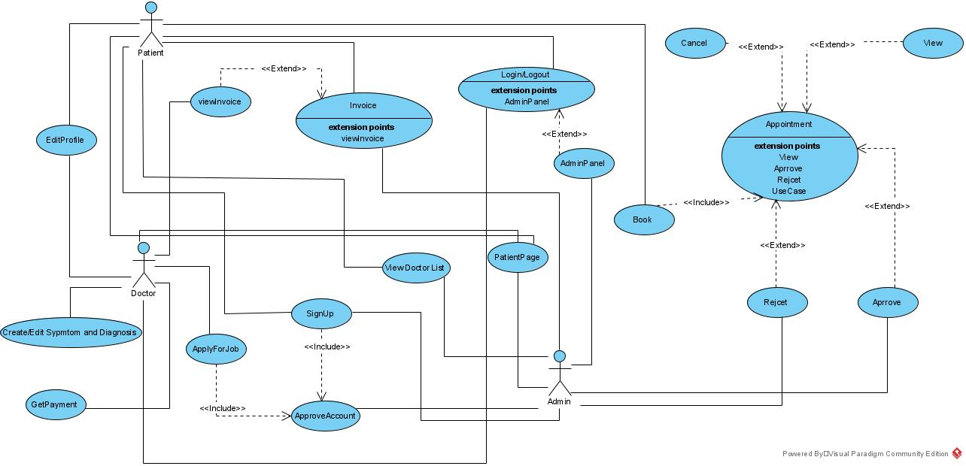

**3.3.2) UML Diagram**

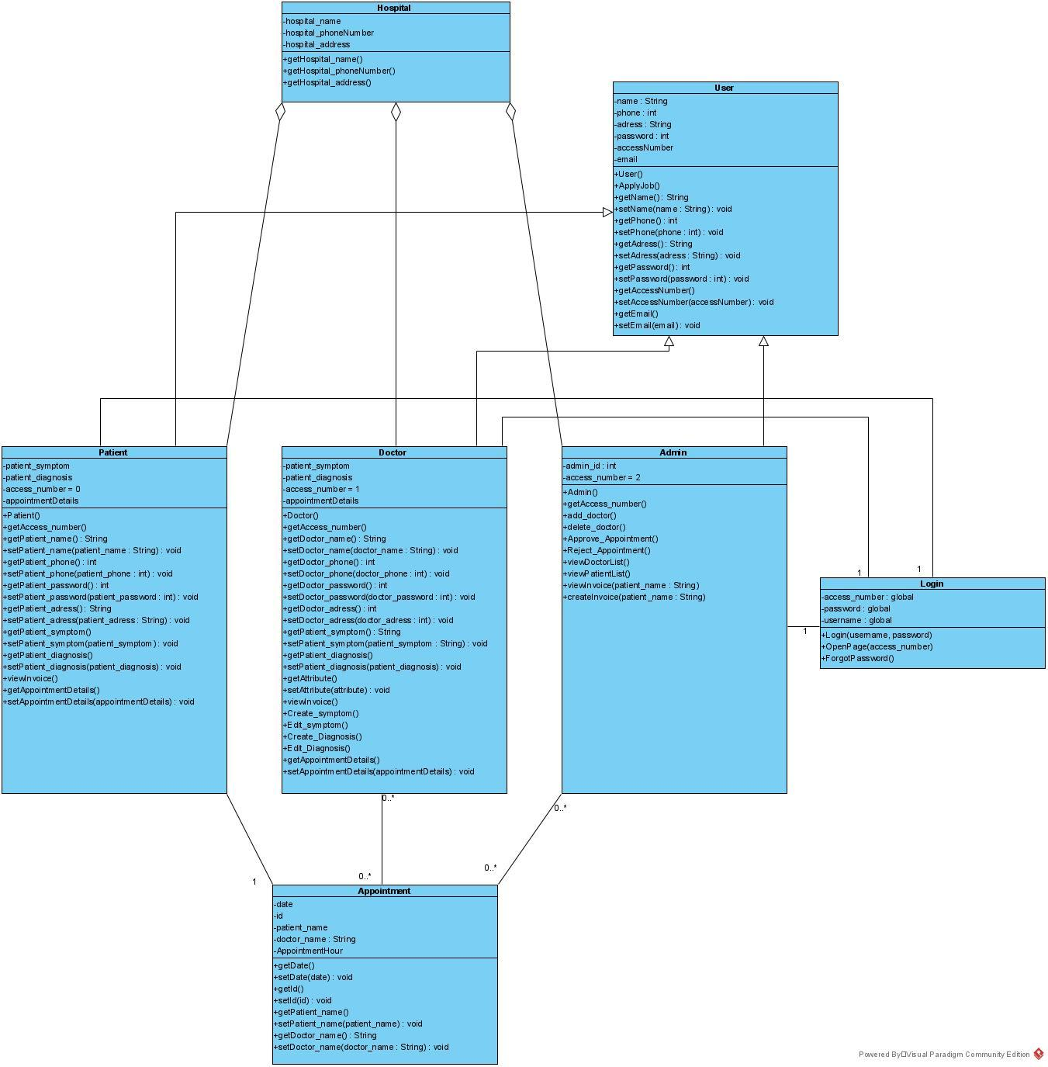

**3.3.3) Sequence Diagrams**

